The University of Nottingham

DEPARTMENT OF MECHANICAL, MATERIALS AND MANUFACTURING ENGINEERING

A LEVEL <4> MODULE, <AUTUMN> SEMESTER 2023-2024

«COGNITIVE ERGONOMICS IN DESIGN»

Time allowed <<2 HOURS>>

ANSWER RUBRIC

Candidates may complete the front cover of their answer book and sign their desk card but must NOT write anything else until the start of the examination period is announced

Dictionaries are not allowed with one exception. Those whose first language is not English may use a standard translation dictionary to translate between that language and English provided that neither language is the subject of this examination. Subject specific translation dictionaries are not permitted.

No electronic devices capable of storing and retrieving text, including electronic dictionaries, may be used.

DO NOT turn examination paper over until instructed to do so

ADDITIONAL MATERIAL: NONE

INFORMATION FOR INVIGILATORS:

Question papers should be collected in at the end of the exam – do not allow candidates to take copies from the exam room.

- (a) Describe Wicken’s model of human information processing. You should include an overview of the model and explanation of its main components in your answer. Use application examples to support your answer.
[23]

- Critique Wicken’s model of human information processing. [10]

Description and application (23 marks):

Answers should describe the following:
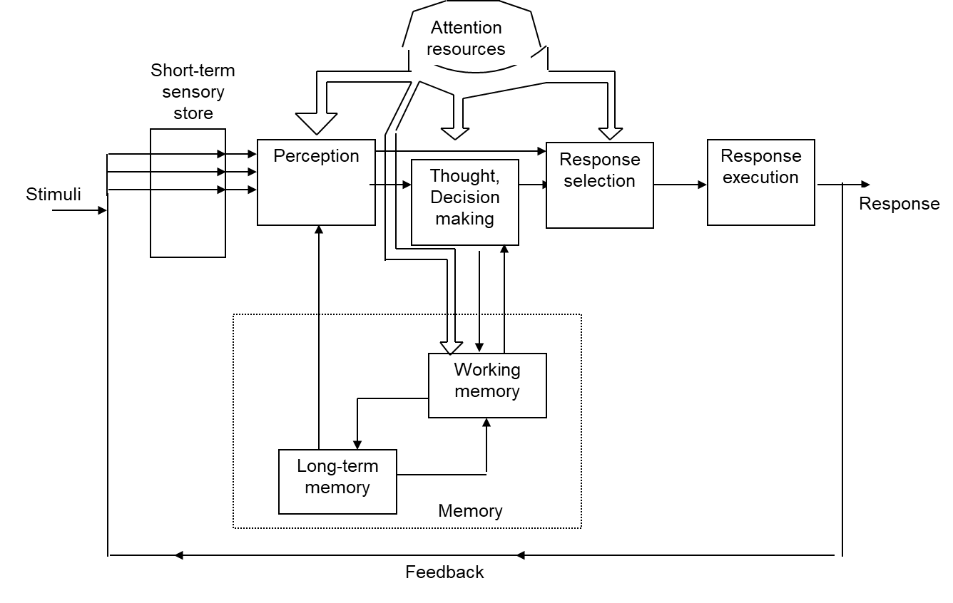

IP assumes that we receive information from the environment, act on it (cognitively), then execute some response.

Begins with some form of sensory memory, which holds vast information, but only for a limited time, in the short-term sensory store.

Any info receiving attention is processed at the perception stage. Perception adds meaning by comparing stimuli with info held in the long term memory (although note that perception can also be guided in a “bottom up” fashion). Perception can lead to immediate reactions, or there may be further processing in working memory. Info in working memory decays rapidly unless rehearsed. Working memory links to long term memory, which both informs WM, and through rehearsal is informed by WM. Working memory guides though/decision making, which in turn drives response selection.

Attention, considered here as a pool of resources, supports perception, thought/decision making (/WM) and response selection and response execution.

A feedback loop provides info on response back to the sensory register.

Can be considered a framework for interacting with systems and for task analysis
Each block is a processing stage (or mental operation) that typically occur in the flow of information.

Marks will be awarded for successful application to appropriate examples.

Higher marks (16+) will be awarded for detailed description of the information processing model, and more extensive application of the material to the example(s). Marks will be deducted for missing components, inaccuracies in the description of the model/components, inappropriate examples.

critique (worth 10 marks):
For critique, students may mention that the analogy of the brain as a computer is limited, and we don’t always (often) follow this process. They may also point out that it is however useful as a guide for analysing human interaction with a complex system and as a tool for communicating human factors needs to engineers.

- (a) Describe the characteristics of mental models.
[16]

(b) Explain approaches that can be used to avoid a design mismatch with users’ mental models. Illustrate your answer with application examples. [17]

For characteristics of mental models:

Answers may describe or present diagrams such as:

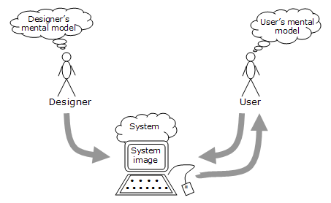

- “Internal psychological representations of a person’s conceptualisation and understanding of a system” (Gentner & Stevens, 1983; Kieras, 1988b; Mayhew, 1992).​
- Dynamic model (because they’re not fixed in an external medium) of system components, how the system works, how components are related, what the internal processes are, and how they affect the components (Carroll & Olsen, 1988). ​
- Tend to be erroneous, incomplete, unstable and fragmented (Norman, 1987; Gordon & Gill, 1989). ​
- There is inertia in mental models – tend to be resistant to change, even when not helpful/incorrect.
- People may have several mental models of a single system, where different models represent different facets of the system (Rouse & Morris, 1986; Wilson & Rutherford, 1989).
- Mental models are really important as a tool to communicate human/user needs to designers
- Mental models are based on experience/memory: Jacob’s law: users spend most of their time on other sites. They prefer your site to work the same way as all the other sites they already know.
- Mental models are what people believe – not based on facts.
- Can be useful to help understand usability problems.
- Understanding the concept of mental models can help you make sense of usability problems in your design.

Higher marks (11+) will be awarded for detailed answers, which give convincing descriptions of most points about mental models described above. Marks will be reduced for missing key points, or inaccuracies in answers.

For part B:

- Mayhew (1992) suggests​
  - Making invisible parts and processes visible to the user​
  - Providing feedback​
  - Building in consistency​
  - Presenting functionality through a familiar metaphor

- To support user’s understanding of how an object works​
  - Cues​
    - Explicit labels that denote interactive parts of an object, and (sometimes) how to use it​
  - Affordances​
    - Perceived and actual properties of an object that determine how an item could be used​
  - Influencing affordances?​
1. Follow conventional usage, both in the choice of images and the allowable interactions​
2. Use words or labels to describe the desired action (e.g., "click here" or use labels in front of perceived objects)​
3. Use metaphor​
4. Follow a coherent conceptual model so that once part of the interface is learned, the same principles apply to other parts.​

  - Constraints​
    - Natural, physical constraints​
Constraints on the way in which an object or part can be moved, how it fits to other objects etc. e.g. the direction of thread on a screw​
    - Semantic constraints​
Cues based on knowledge of the meaning of a situation, e.g. knowing that if a pen lid is to prevent ink drying out, it will be placed over the part of the pen where the ink is exposed​
    - Cultural constraints​
Cues based on social conventions e.g. the order of lights on a traffic light​
    - Logical constraints​
Cues based on a logical relationship between the spatial or functional layout of components e.g. the last of switch options when functions of all others known​
  - Mappings​
    - The relationship between two things, such as controls and their movements and results in the world, e.g. steering wheel​

In case of a mental-model mismatch, there are two main options:
- Make the system conform to users' mental models (preferred) i.e. design the system in accordance with the users’ mental model
- Change the users' mental models so that they more accurately reflect your system, .e.g through explanation, labels, making the UI more transparent.

Higher marks (12+) will be awarded for detailed answers, which give convincing descriptions of most points about approaches for avoiding mental model mismatch. Marks will be reduced for missing key points, or inaccuracies in answers.

{note that the mental models lecture also included concepts such as Norman’s seven stages of action; knowledge in the head vs. knowledge in the world, and SRK behaviour – some (reduced) marks will be awarded for appropriate mention of these associated concepts}.

- (a) Provide an overview of one objective and one subjective method for measuring Situation Awareness.
[17]

(b) Critique both methods presented in part (a). Use application examples to support your answer.
[17]

One method could include SAGAT (although this is often described in the literature as an objective measure, given its reliance on participant responses, I would accept this if given as an example of a subjective method):

Overview would be based on:

- SAGAT (Endsley 1988)– simulation based, and simulation is paused to query aspects of SA. Based on perception, comprehension, projection.
  - Define the tasks to be analysed
  - Conduct Hierarchical Task Analysis (HTA)
  - Conduct an SA requirement analysis
  - Select participants
  - Brief participants
  - Pilot run
  - Perform task (on appropriate simulation)
  - Pause simulation to ask pre-defined SA queries
  - Compare answers to what was actually happening
  - Calculate SA score

A subjective method could include SART, with answers mentioning some of the following:

- Situation Awareness Rating Technique (SART, Taylor, 1990)
- Quick method of self-assessing SA
- Subjective rating method, against themes of
  - Demands on attentional resources
  - Supply of attentional resources
  - Understanding of the situation

Responses could summarise key aspects of this table:

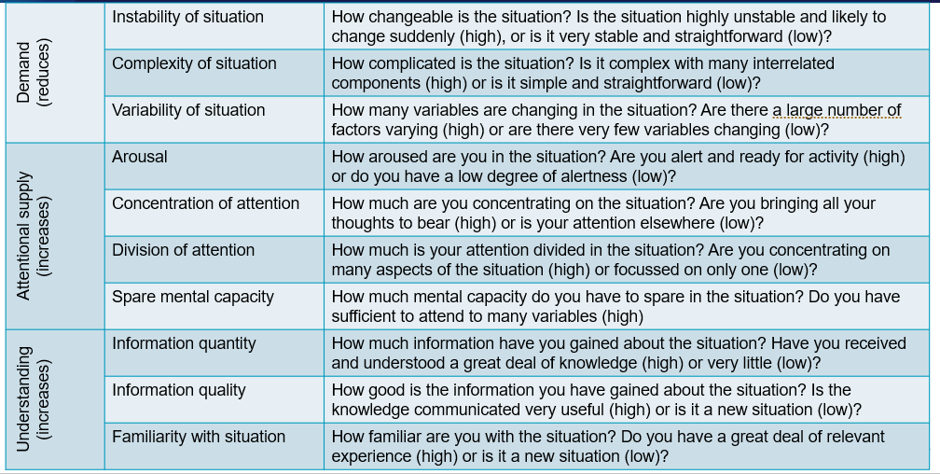

And SART SA=U-(D-s)

Higher marks (12+) will be awarded for comprehensive answers, correctly covering most of the main points about each method. 10+ marks will be awarded for less comprehensive answers with minor accuracies. 8.5+ marks will be awarded for responses which report only the basics. <8.5 marks will have missed key points about the methods, provide limited information, or have serious factual inaccuracies.

Marks will be awarded for any other valid answer reporting methods from the wide range of SA methods, including process indices, behavioural measures, performance measures, freeze-probe techniques, self-rating techniques.

SAGAT Critique could include:

Pros:
- SAGAT is a direct measure of participant SA
- Extensively used – wealth of validation evidence. The most widely used SA measurement tool.
- Task-interruption method avoids issues of recall when asking about SA after the task, or confusing SA with performance.
- High face validity.

Cons:
- requires high fidelity simulator
- queries are intrusive to primary task/pausing is disruptive
- limited applicability in the real world
- not suitable for team SA
- is based on a simplistic model of SA
- development effort is required to use it in domains other than aviation
- requires considerable preparation, including SA requirements analysis

SART:

Pros
- Quick to administer, low cost
- Applicable across a range of applications
- Widely used method
Cons
- Can confuse SA with performance
- Respondents may be unaware of their own limited SA
- Retrospective – memory may not be accurate
- Intrusive if administered during task
- Limited portion of SA – nothing on projection

Higher marks (12+) will be awarded for comprehensive answers, correctly covering most of the main points about each method. 10+ marks will be awarded for less comprehensive answers with minor accuracies. 8.5+ marks will be awarded for responses which report only the basics. <8.5 marks will have missed key points about the methods, provide limited information, or have serious factual inaccuracies.

END

